Welcome 6th grade students to Soccer 101
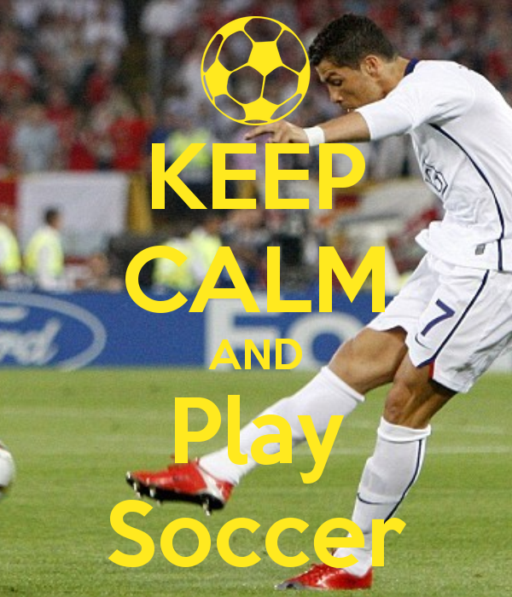
Welcome
Students will be able to assess their knowledge and their skills of soccer.
Description-
This site will give students basic information regarding the knowledge and skills regarding soccer.
Grade level- 6th grade
Curriculum- Health/P.E
Author- Mr. Aguilar

Introduction
For those of you who do not know the skills and knowledge of soccer, not to worry.

This site will give you the necessary knowledge of soccer, and you will be able to assess what you have learned from that knowledge.

This site will give you the necessary skills of soccer, and you will be able to assess what you have learned from those skills.

At the end of the assessments, students will be able demonstrate and apply knowledge given regarding the game of soccer.

Objectives

Knowledge

- Do you know the rules of soccer?
- Do you know how many players should be on a team?
- Do you know all the defensive, middle, and offensive positions of soccer?
- Do you know the offensive objectives of soccer?
- Do you know the defensive objectives of soccer?
- Do you know, what are the basic skills of soccer?
- Do you know, how many substitutions can a team have?
- Do you know how long each half of soccer is?

Skills

- Can you dribble the ball consistently with both feet without looking at the ball?
- Can you strike the ball consistently with both feet?
- Can you trap the ball effectively?
- Can you kick/pass the ball with both feet using the inside and the outside of the ball consistently?
- Can you run/jog for about 30 minutes consistently?

Assessments

Below are some links to assess your knowledge of soccer and assess your skills of soccer.

Knowledge
http://www.proprofs.com/quiz-school/story.php?title=soccer-quiz_7

http://www.funtrivia.com/trivia-quiz/Sports/All-About-Soccer-305144.html

Skills

Have an individual test you on the following soccer test. This test will be similar to the one you are taking on the day of the final.
http://www.aahperd.org/naspe/publications/teachingTools/coaching/upload/Soccer-Skill-Performance-Tests-2.pdf

Students, this website will help you improve your skills, and most importantly, it will be fun.
https://www.playisoccer.com/players

